TASK-1:
Update four dropdowns according to given excel file
TASK-2:
Create UI for Super Admin Dashboard
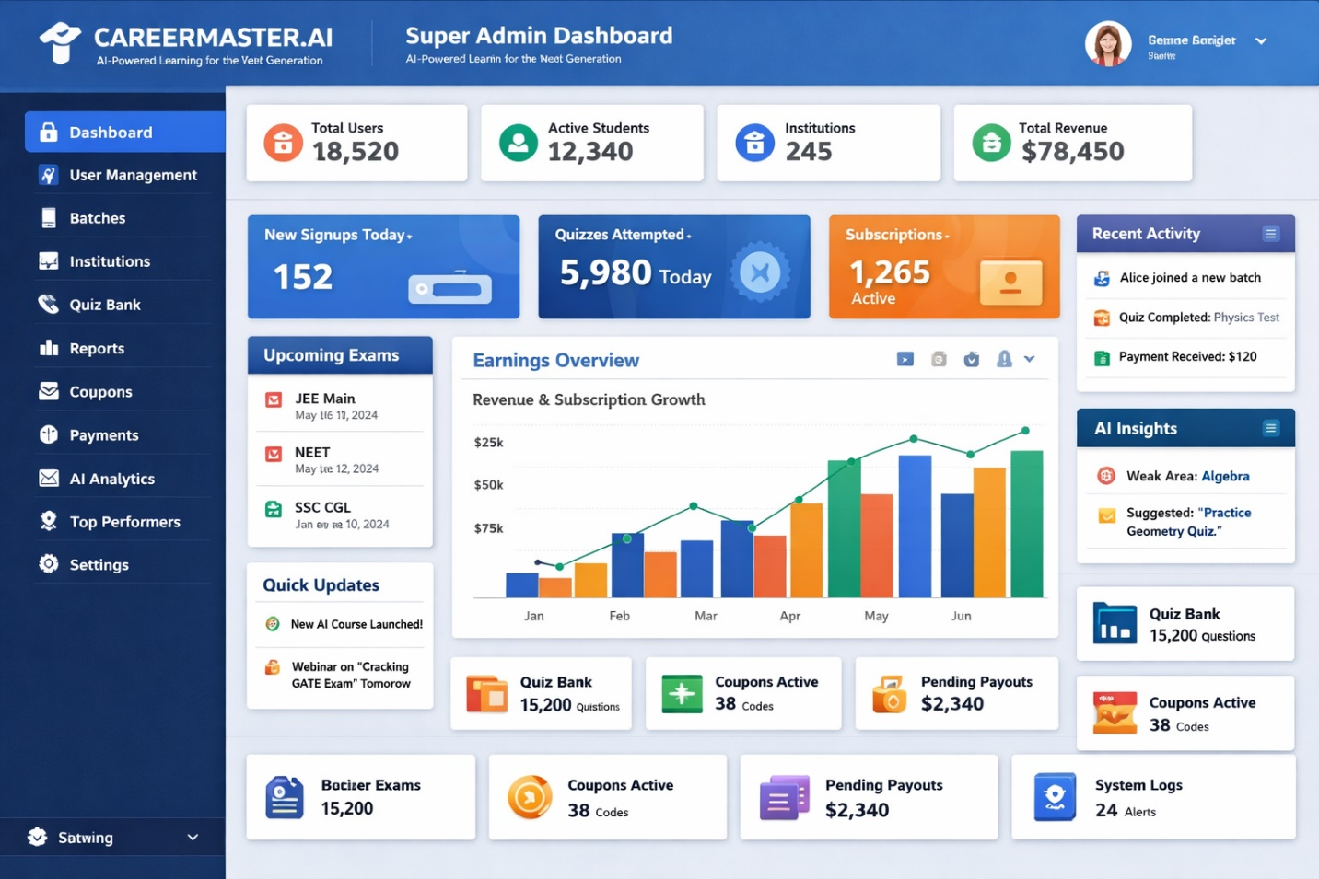
OR
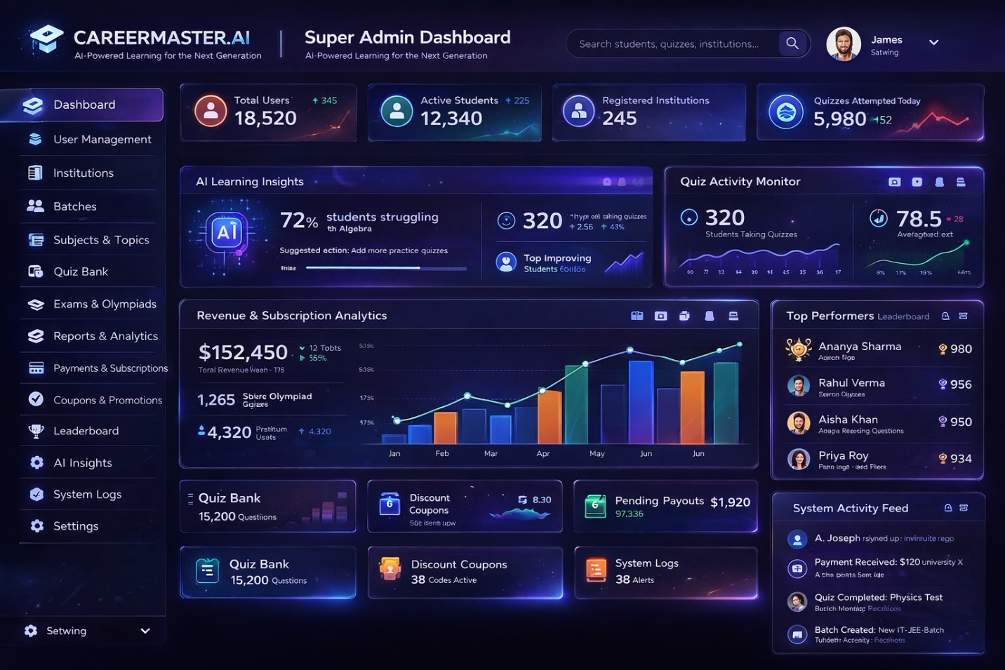

TASK-3:
SUBJECTS MAPPING PAGE
Add/Update/Delete/Sort/Search options page for Super Admin to Assign subjects
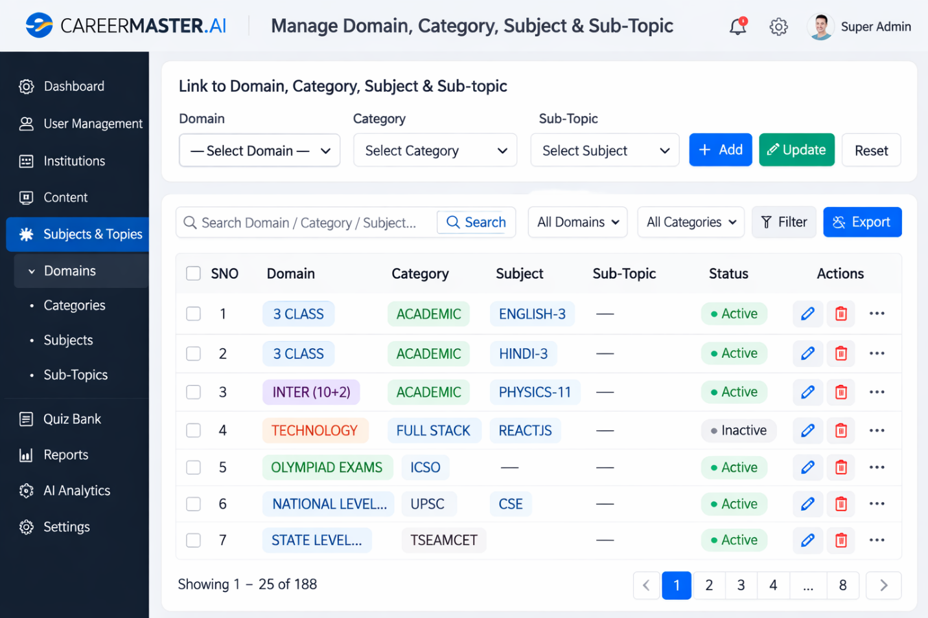

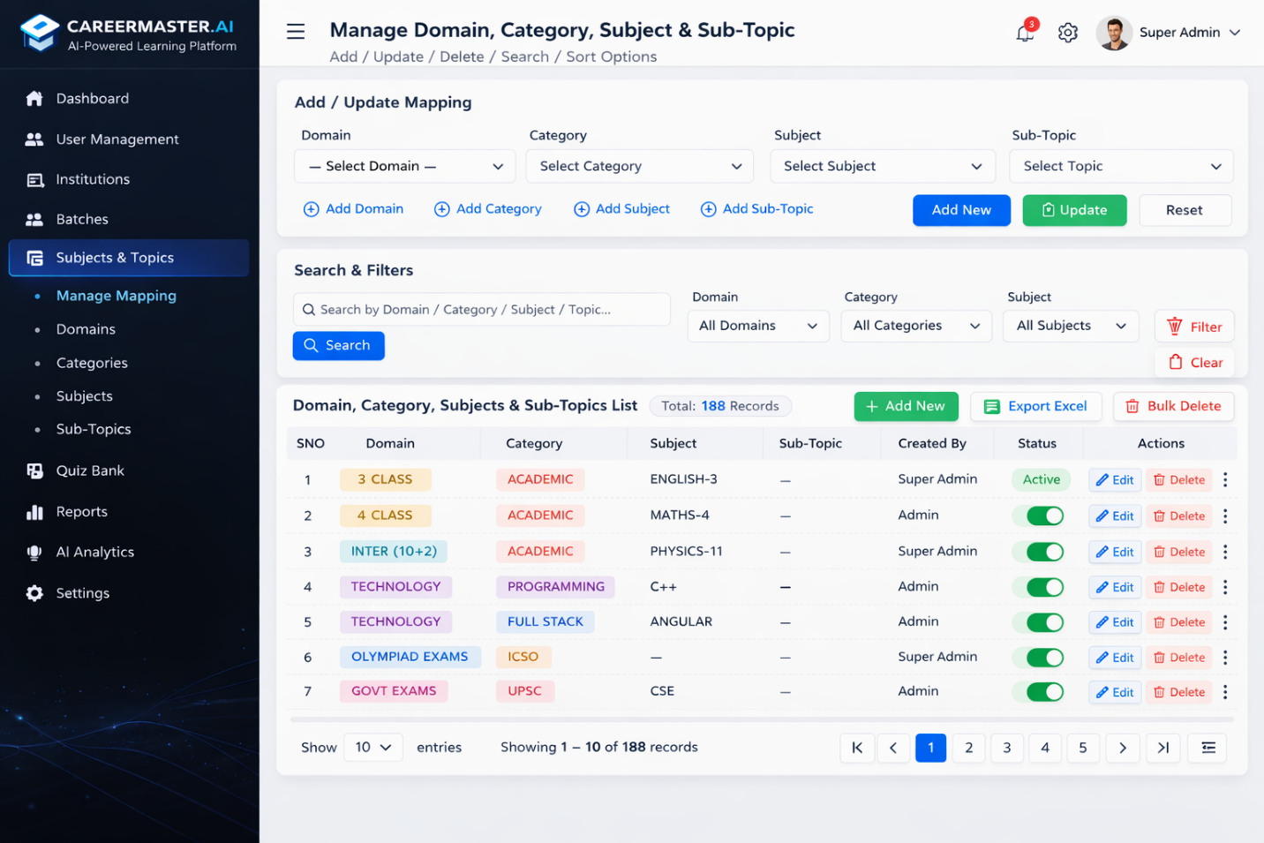
TASK-4
Subjects Delete Page
- Subjects should be deleted domain wise / Category wise / subject wise / topic wise/ level wise
Provide a check box to select all, individual options

TASK-5 RECTIFY ERRORS
- In the quiz management once I click on delete option for any quiz, it is not updating immediately. So a confirmation message should be displayed and page should be refreshed with updates
- In quiz management-> level (basic) is not working
- From User side->Level-Basic not working
- Once I add and delete a Quiz at Admin level it is not updating quiz count in user portal, showing wrong count
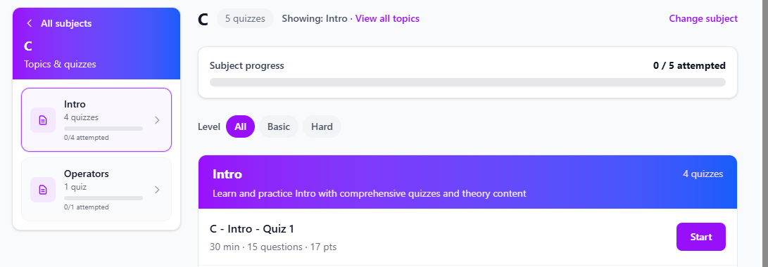
- At user level Quizzes should be displayed only subjects for which he has subscribed (Filter, search options not required here)
Subscribed Subjects: Subject-1, Subject-2 etc.
- At user level in profile showing error for date option
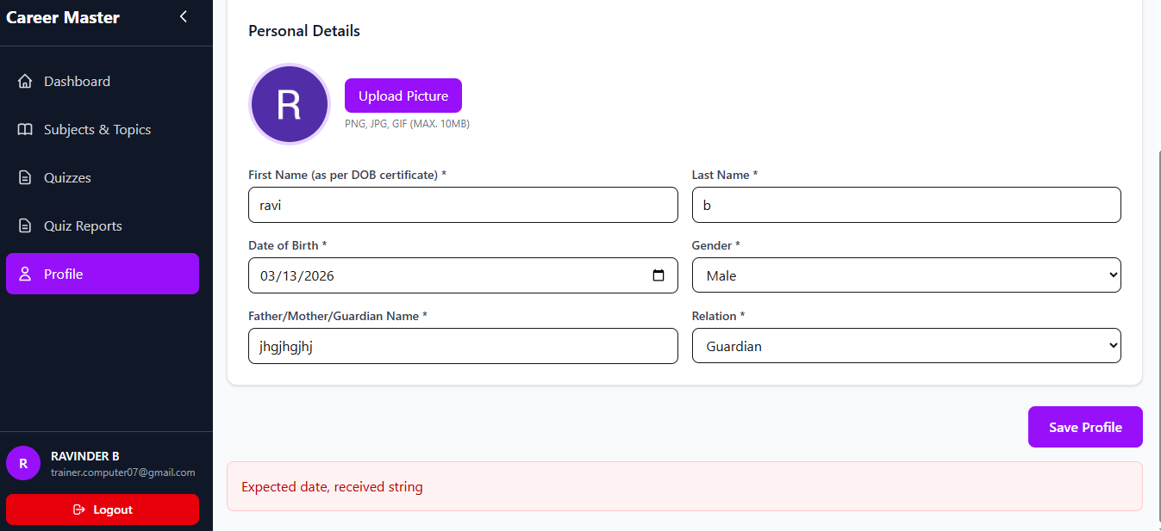

In the User management -> Once click on delete option it is working but showing wrong error message “ failed to delete user”
